SLAP Handbook

Prepared by

Hemanshu Patel

April 10, 2015

# Introduction

Two recent satellite missions feature L-band microwave observations at their core: the Soil Moisture Ocean Salinity (SMOS) mission from ESA (Kerr, et al, 2001) and the Aquarius sea surface salinity mission from NASA (Lagerloef, et al 1995). In the near future, NASA plans to launch the Soil Moisture Active Passive (SMAP) mission (Entekhabi, et al., 2010), to provide global soil moisture products with resolutions in the 10—40 km range. SMAP and SMOS, with their focus on soil moisture, are particularly sensitive to the natural heterogeneity of land surface conditions (vegetation, topography, soil texture, surface roughness, open water). Their soil moisture retrieval algorithms are relatively complex (Wigneron, et al, 2007), particularly SMAP’s combined active-passive algorithm—the key to achieving the highly-desired 10 km spatial resolution by combining the higher-resolution but noisy active radar observations with the lower resolution but more accurate passive radiometer observations.

Airborne simulators have played a critical role related to these missions. A partial list would include the ESTAR instrument (Swift et al, 1995) used to develop and demonstrate early soil moisture retrievals at large scales using passive-only observations, the PLMR and EMIRAD instruments (Panciera, et al, 2008; Skou, et al, 2005) used extensively for calibration/validation of SMOS, and the PALS instrument (Wilson, et al, 2001)—one of the few combined radar-radiometers. Recently, the demand for L-band airborne simulators has increased in the USA as new applications beyond just SMAP have appeared, leading to the development of a new airborne simulator named Scanning L-band Active Passive (SLAP) built by NASA’s Goddard Space Flight Center. SLAP is available for algorithm refinement work prior to SMAP launch, for post-launch calibration/validation activities, as well as other applications that rely on L-band sensing.

Several key features of SLAP are shown below:

* A new thin aerodynamic antenna to permit simple accommodation on multiple aircraft
* A real-aperture radar at 1.26 GHz and a radiometer at 1.4 GHz to match the SMAP frequencies
* A dual-frequency dual-polarized antenna enabling quad-pol radar and 4-Stokes radiometer operation with the same antenna and matching the SMAP incidence angle of 40 degrees
* Conical scanning via a rotating antenna to match the conical scanning of SMAP
* Use of identical or nearly-identical RF front end parts as the SMAP radiometer, for high fidelity simulation of SMAP performance
* A digital backend that exactly mimics the SMAP digital backend, including RFI processing code
* Active thermal control of critical components for high stability/repeatability
* Radiometer is 4-pol (same as SMAP); Radar is quad-pol (SMAP is tri-pol)
* Can use AESMIR installations on P-3 and C-130
* Uses ESTAR ground calibration target
* The new Scanning L-band Active Passive (SLAP) instrument had its “1st light” flight the week of Dec 2, 2013, with additional flights through Dec 18.
* SMAP launch is in early 2015 and SMAP is considering one post-launch calibration/validation campaign in the summer of 2015 or 2016.  SLAP is ready in 2014.
* Soil moisture ground truth was collected by a Goddard-USDA team during the Dec 2013 flights.  Comparison with SLAP-derived soil moisture is ongoing.
* SLAP’s innovative thin antenna makes SLAP compatible with several new aircraft plus the usual P-3; it is currently installed on a King Air from NASA Langley.
* SLAP can observe soil moisture, soil freeze/thaw state, ocean salinity, sea ice melt ponds, & ice sheets.

A block diagram of SLAP is shown below.

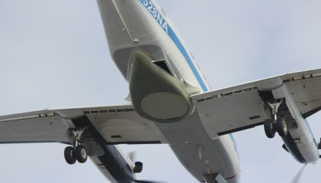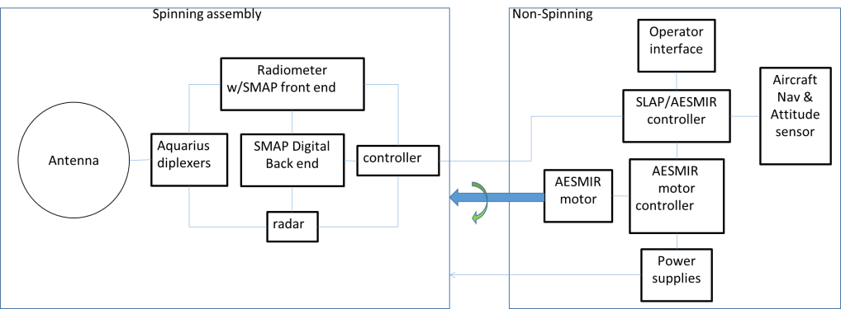

Several images of SLAP in flight during the December 2013 campaign are shown below.

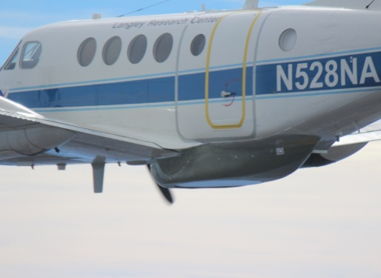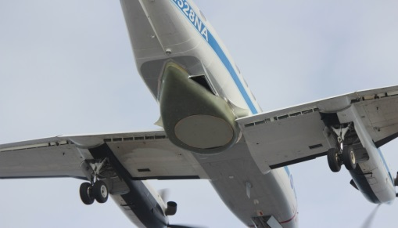

Figure 1. SLAP on King Air aircraft During December 2013 Campaign

# Summary of Radiometric Data Processing Steps

## Reading in Raw Data

The raw data for SLAP, in its current format as of the May 2014 iPHEX flights comes in ten minute data sets. The radiometer data are in a format such as RADTELEM_20140521T142000.slapbin, which have the following naming convention. The scan angle data replaces RAD with MOT and the DAQ temperature data replaces RAD with DAQ but the rest of the naming conventions apply. The radiometer telemetry (RADTELEM) data are read into MATLAB workspace files initially for easier processing down the line. The geolocation data is provided by the OxTS in a comma separated variable file (csv) in Microsoft Excel. It must be read into a MATLAB workspace variable as well. Next the encoder telemetry (ENCODERTELEM) and data acquisition telemetry (DAQTELEM) files are read in. The former has the scan angle data while the latter has all of the housekeeping information including instrument temperatures and the outside air temperature (OAT).

Table 1. SLAP Data Nomenclature

|  |  |
| --- | --- |
| RAD | Radiometer |
| TELEM | Telemetry |
| 2014 | Year |
| 05 | Month |
| 21 | Day |
| 14 | Hour |
| 20 | Minutes |
| 00 | Seconds |
| .slapbin | Binary File Extension |

## Time Tag Definitions

The radiometer data comes in 2 ms increments. There is an anomaly with the radiometer time tags that is explained in Appendix 1. Once the time tags are “reconstructed”, they must be split up further. The reason is the structure of the antenna observation data. It is in a data packet of 4 PRIs per time tag so there are four independent observations every 2 ms. Therefore, the data is in effect taken every 0.5 ms. For this reason, the “reconstructed” radiometer time tags are interpolated to a 0.5 ms interval.

Geolocation data comes from the OxTS which provides data every 10 ms. There was a 16 second offset between the geolocation time tags and the other data products. The reason is the OxTS records time data in UTC time, which is behind GPS time by 16 seconds, which is the time system used by the other data products.

Finally, the scan angle data is provided in the encoder telemetry (ENCODERTELEM) files at a 10 ms frequency. To make an apples-to-apples comparison, the geolocation and scan angle data are interpolated down to the frequency of the radiometer data, 0.5 ms. Before the iPHEx campaign, the resolver scan angles were used instead of the encoder scan angles, which are found in the motion telemetry (MOTTELEM) files. There is transient time tagging in the MOTTELEM files. Sometimes the data frequency at the beginning of the file is significantly larger than 200 ms. For example, on May 21 at 1520 UTC, the file starts out as:

Table 2. Example of MOTTELEM Transient Data

|  |
| --- |
| Time in HH:MM:SS.### Date Scan Angle  15:18:38.288 05/21/2014 33182 0.040000 0 0 C 0 0  15:18:38.803 05/21/2014 41548 0.300000 0 0 C 0 0  15:18:39.003 05/21/2014 44868 0.160000 0 0 C 0 0  15:18:39.203 05/21/2014 48183 0.380000 0 0 C 0 0 |

Which means it has a 515 ms time jump before it starts increasing continuously at 200 ms. This is not an issue as the corresponding scan angle difference from the first to second data points is proportionally larger than the difference between the second and third data points. This makes interpolation using the MOTTELEM time tags easy. The ENCODERTELEM scan angles have similar ease of use with regards to interpolation.

There are no similar issues with the geolocation data. The geolocation data is provided as a MATLAB mat workspace file which has all of the data for a flight in one file. Therefore, the only requirement is to find the geolocation data that corresponds to the time indices of the ten minute data set that is currently being processed.

For calibration (cal) using the internal target observations, the independently measured IMA_H_SWITCH and IMA_V_SWITCH temperatures needs to be obtained. This comes in the DAQTELEM file. These temps are measured at a 200 ms frequency. This information is not currently used since the internal target is not being used for cal.

## Correction of Offset in Power Data in Radiometer Telemetry

The majority of the second moment, or power, flight data in the region of interest, which is referred to as the Mow the Lawn (MTL) area in the iPHEx campaign since it consists of flight lines that are drawn out to produce an rectangle of observations on the ground, is in a data collection mode called “long period cal”. This means there are four observation packets through the antenna then two packets which observe the internal cal target. Since each data packet has four PRIs, this means there are 16 observations through the antenna then 8 observations of the internal cal target. There was an issue with the antenna observation data shifting into the internal target observation data packets and vice versa in the iPHEx campaign data. This offset changed for different flights and sometimes during the same flight, but with careful examination, it was accounted for. More detail on this is given in Appendix B. This offset correction was only necessary in the iPHEx campaign data.

## M2/M1 Correction

The second power, or M2, data has to be corrected using a combination of the M2 and first power, or M1, in-phase and quadrature, or I and Q, data. Using the raw M2 counts isn’t enough to emulate the output of an analog square-law (diode) detector. To do that, the M1 component must be subtracted out. Otherwise, a time-varying bias would be left. The equations that specify this correction are given in Appendix C. This correction must be done for all SLAP radiometric observations.

## Periodic Noise Mitigation

There was a periodic noise in the SLAP antenna observations from every flight and ground calibration test prior to and including the Februrary 25, 2015 flight. This noise was not evident in the reference data. An empirical algorithm to remove the noise is described in Appendix D. The source of it has been narrowed down to several causes which have been corrected for. Newer data sets do not show the noise, starting with the April 1, 2015 radar test flight.

## Geolocation

Once these problems were resolved, there was a full set of antenna observation counts, internal observation counts, geolocation data, and scan angle data all at the freq of 0.5 ms. The next step is to perform the geolocation. This meant using the provided altitude, latitude, longitude, elevation, scan angle, heading angle, roll angle, and tracking data correctly to geolocate each observation. More detail on the geolocation is provided in Appendix E.

## Averaging by Scan Angle

Next, for plotting purposes, the data is reduced. Specifically, one data point is plotted every 6 degrees in scan angle on Google Earth. Therefore, all of the data points within 6 degrees in scan angle are averaged. Since each scan takes 4 seconds and there is an observation every 0.5 ms, 6 degree averages equate to

Averages are taken for the geolocation, scan angle, and antenna observation data.

## Obtain Half-Scan Data

Next two separate filters are applied to the data. The first is designed to only plot the fore or aft half-scan of the data. This filter is accomplished by using the provided heading angle along with the scan angle. The combined angle is expanded 90 degrees on either side of the track angle to get the full fore half-scan. The track angle is used because it provides the fore half scan with respect to the aircraft’s ground track, not its heading in the air. Combined angle values within that range are plotted for the fore half-scan and combined angle ranges outside of those values are plotted for the aft half-scan.

## Filter Roll Data

The second filter removes data when the plane was banking. This is done because the counts values are affected when the plane isn’t flying level because the incidence angle is affected during a turn.

## Two Point Calibration

This gives a final set of time tagged antenna counts that are then calibrated before plotting. There are two calibration procedures that were attempted. The first used the internal target for calibration for the May 5th and May 9th data sets because it was the only calibration source we have that is time varying. The calibration scheme for May 21st , which interpolated between the sky observation and the foam box observation, is discussed later. The internal target was continuously observed in the “long period cal” mode, every two of six data packets so there is a large dataset to calibrate with. The independently recorded IMA_H_SWITCH temp is interpolated to the time frequency of the antenna observation data. Then for each time step, a two point linear interpolation is performed between the sky cal data point and the internal cal target observation at that time. The sky cal data point was taken before the flight campaign on April 21st 2014 when SLAP was not attached to the aircraft. SLAP was turned to face the sky and the counts values when observed through the antenna were recorded. A uniform sky brightness temperature (Tb) of 10 K was assumed. The foam box brightness temperature was assumed to be equivalent to the air temperature which was recorded to be 297.16 K on April 21st during the foam box cal. Examples of the sky and foam box observation data counts values are shown in the figures below. It is noticeable that there are groups of relatively constant data points followed by blips of high counts and low counts. To determine a mean value of sky and foam box observation counts and to find noise equivalent delta temperature (NEDT), the data sets were manually mined to pick out three consecutive spans of relatively constant counts values which were averaged to give individual values for the sky cal and foam box cal H-pol and V-pol counts that are shown in the table below. Each span consisted of 1000 data points, where each data point was taken 0.5 ms apart. Therefore, these spans were 0.5 seconds long and the total time of observation is 1.5 seconds.

The rest of the process to determine NEDT is shown in Appendix F. The calculated values of NEDT are also shown in the table below.

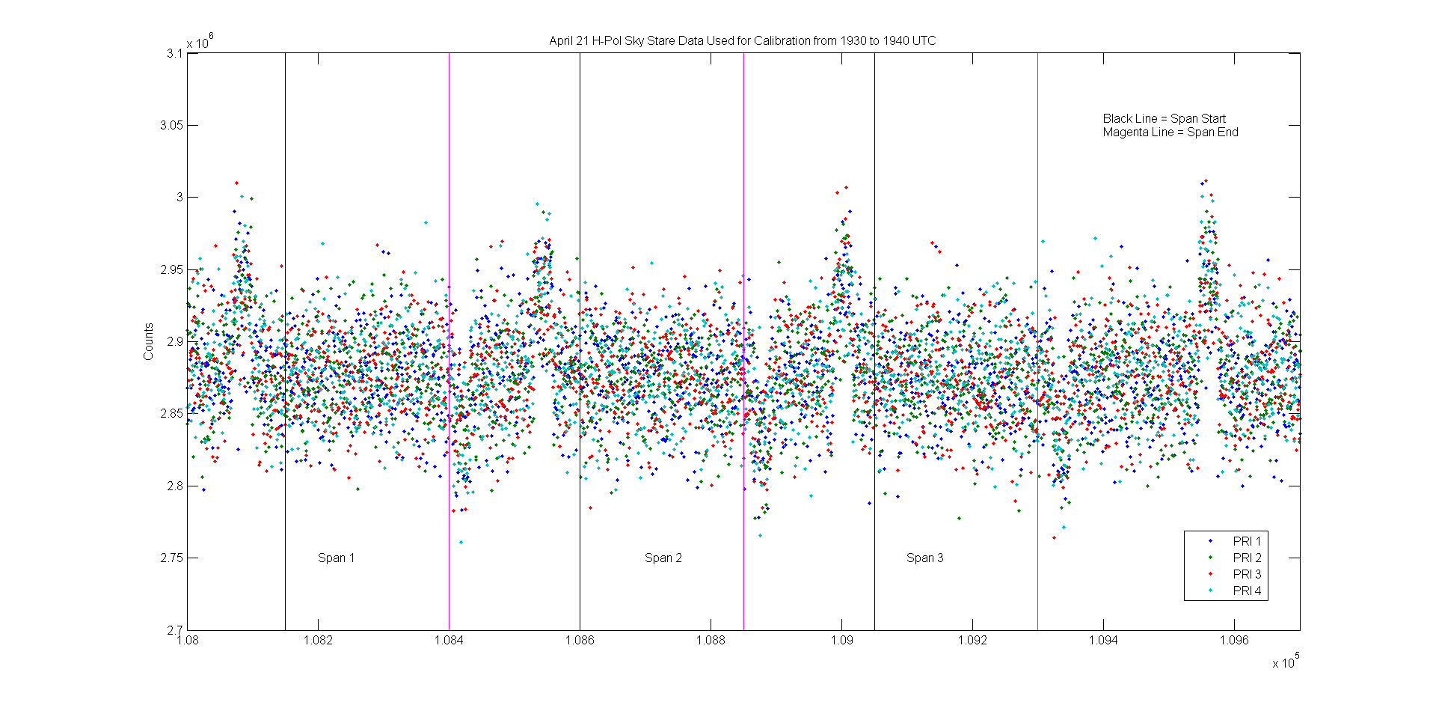

Figure 2. Three Stable Spans of H-Pol Counts Used for Sky Calibration from April 21, 2014

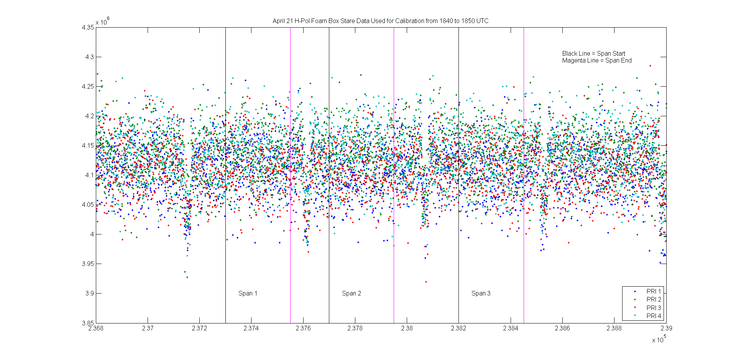

Figure 3. Three Stable Spans of H-Pol Counts Used for Foam Box Calibration from April 21, 2014

Table 3. Sky Counts and Foam Box Counts Determined from the April 21st Data

|  |  |
| --- | --- |
| Name | Mean Counts Value |
| Sky Cal H-Pol | 2.9e+06 |
| Sky Cal V-Pol | 2.5e+06 |
| Foam Box Cal H-Pol | 4.1e+06 |
| Foam Box Cal V-Pol | 3.7e+06 |
| NEDT for H-Pol | 0.164 K |
| NEDT for V-Pol | 0.148 K |
| NEDT Observation Time | 1.5 seconds |

For May 21st flight, there was no “long period cal” during the MTL section so this required another calibration scheme. The sky cal and foam box cal observations were used to convert counts to Tb in Kelvin instead. This is not as advantageous since there were only two values for these cal types for the entire flight as opposed to a time series of internal target observation values. However, there was the Jordan Lake, NC, flyover cal data point which was used to independently check the accuracy of the calibration scheme. During all of the flight days, the observations over Jordan Lake were taken while the airplane was rolled 40 degrees and SLAP’s scan motor was disabled so that SLAP could continuously stare at the lake at a zero degree incidence angle. An example of this is shown in the figure below.

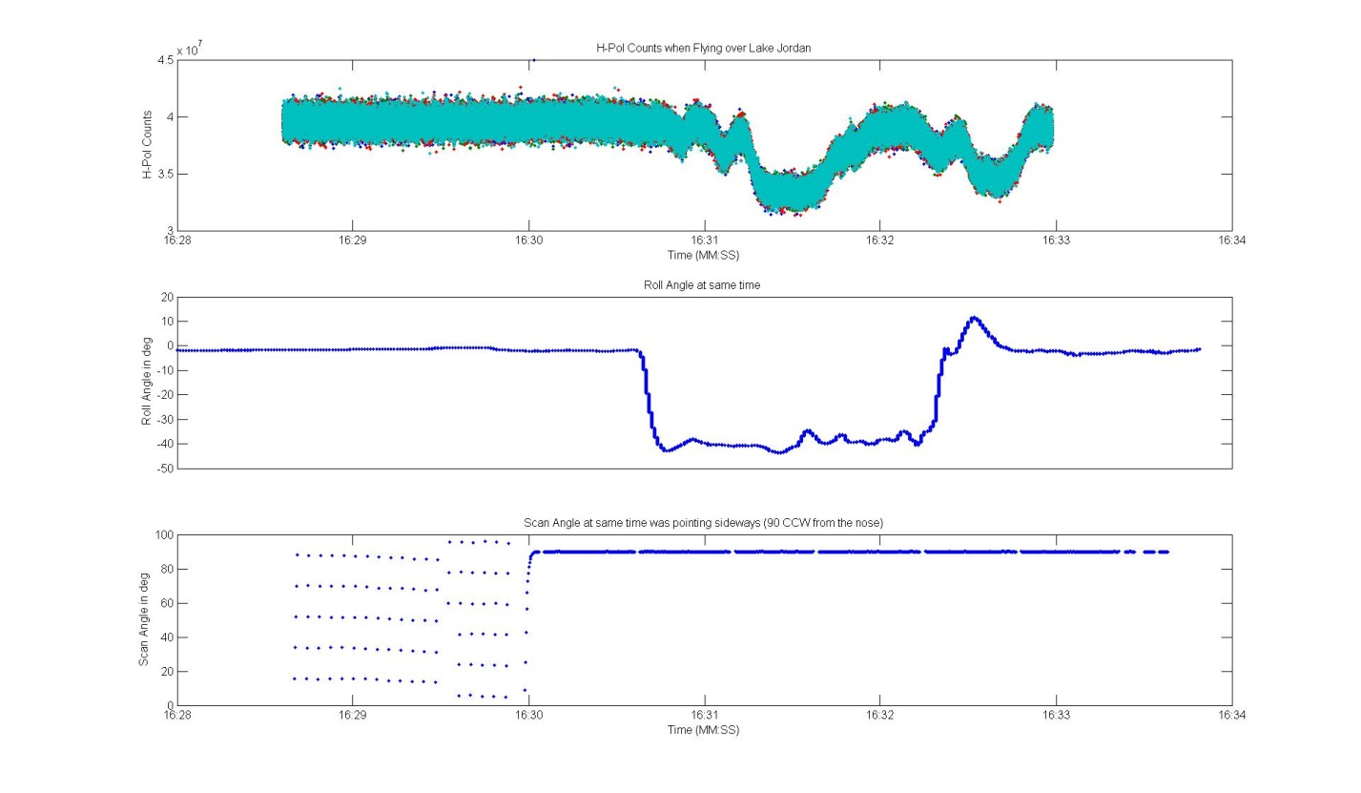

Figure 4. SLAP H-Pol Counts, Roll Angle, and Scan Angle when Observing Jordan Lake

A ground team also measured the water temperature with probes on the days of the SLAP flights. The lake cal data isn’t used in the two point calibration because it is the least reliable of the three cal types since the observations are subject to contamination from nearby land among other issues.

## Google Earth Image Generation

The two point linear interpolation produces a brightness temperature (Tb) data point for each time and geolocation coordinate set that is finally plotted on Google Earth. This is done by creating a Google Earth KML file using MATLAB’s fprintf function. In short, the procedure takes a Tb value and its associated geolocation information and creates a colored circle around that lat/lon coordinate that is plotted in Google Earth with an assigned color based on the Tb value within a color bar range.

## Conversion to Soil Moisture

There is an option to convert the Tb values into soil moisture using the SMAP single channel algorithm. The rest of this handbook only deals with brightness temperature.

## Streaks of High Brightness Temperature Values

On all of the flight data on the four days of science flights during the iPHEx campaign, two distinct streaks are noticeable, only in the horizontal polarization, at the same azimuth angle for each scan. This was probably due to some interference on the aircraft. An example of the streaks is shown below as well as an image after streak removal. These streaks were not present in later SLAP flights.

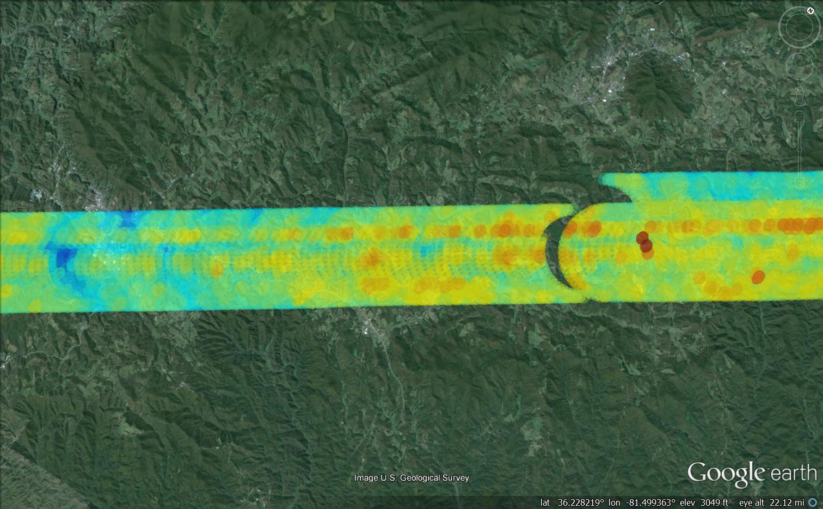

Figure 5. Flight Data Before Streak Removal

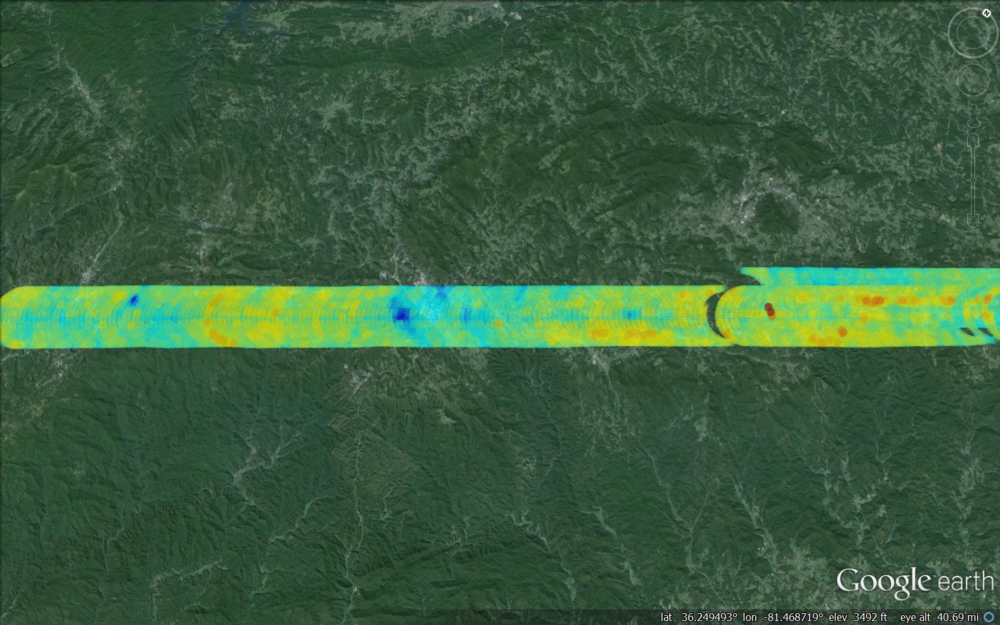

Figure 6. Flight Data After Streak Removal

The streak removal process starts with associating each Tb data pixel and its corresponding geolocation information to scan angles at six degree intervals. Since the steaks were evident at constant scan angles, this partition makes it easy to remove them without affecting the other data. The streaks were only slightly higher in Tb than the surrounding data so multiplying them by 99% in counts values was enough to make their Tb values similar to surrounding pixels. Figure 4 below shows radiometer observed M2 power (counts) values plotted against constant scan angles for the fore half-scan. The data is initially plotted in blue before streak removal and in red after streak removal. It is evident there are two steaks at approximately 90 and 96 degrees and 126 and 132 degrees. This algorithm only reduces the values at those scan angles while ignoring the less common high counts values at other scan angles. Note that this is a part of the MTL section where the aircraft was flying in the southwest direction since most of the data is at scan angles that range from 40 to 210 degrees measured CCW from due North.

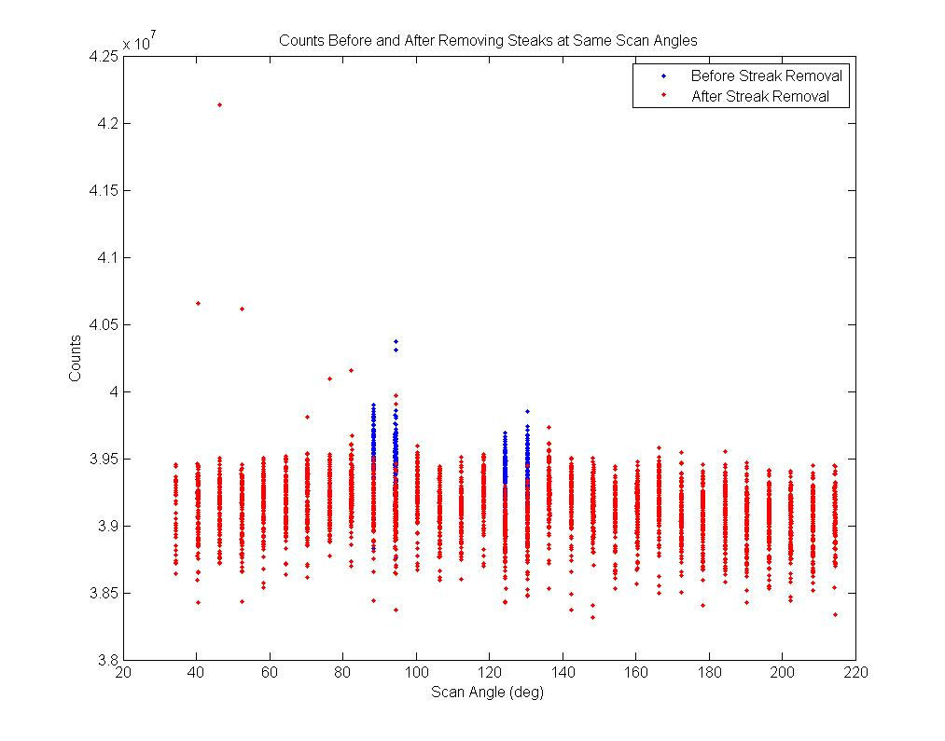

Figure 7. Example of Streak Removal in Counts vs Scan Angle Plot

In Figure 5, counts are plotted against their data indices. This plot shows how the algorithm chooses only the high counts values associated with certain scan angles to reduce and not any other high counts values that could be due to RFI.

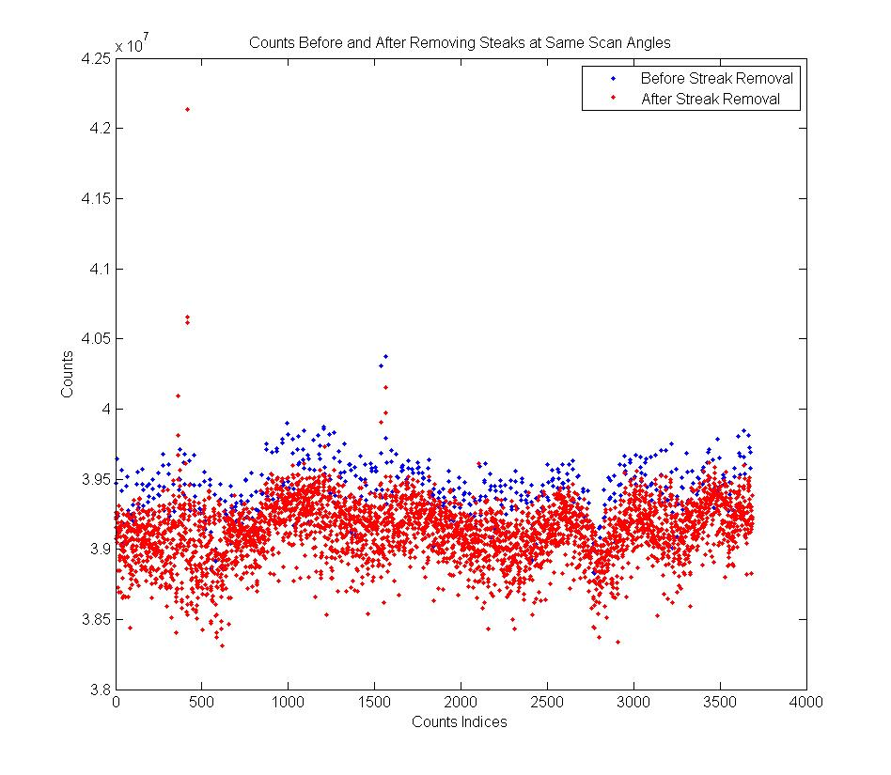

Figure 8. Steak Removal in Counts Domain

## Example Google Earth Images

Finally, we have calibrated Tb data for May 21st. These two figures show the northeast and southwest facing flight lines, respectively. There were split this way for visualization purposes as they would overlap otherwise. The bottom two flight lines are warmer in color because they are over terrain that faces the Sun during this time of the year in western NC.

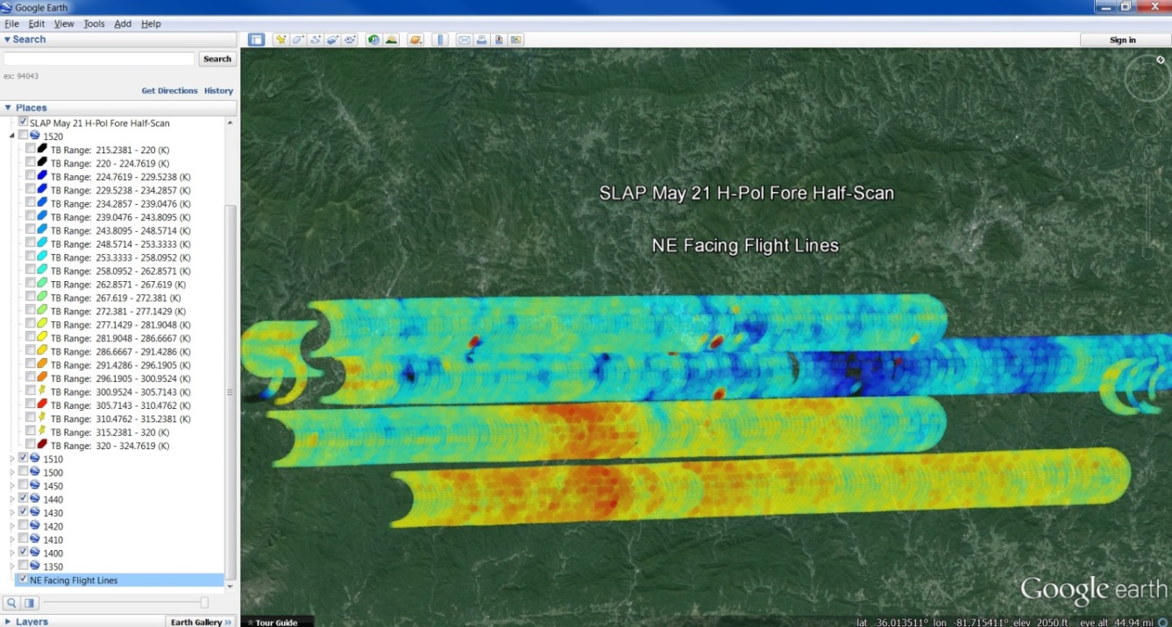

Figure 9. May 21st NE Facing Fore Half-Scan Tb Data

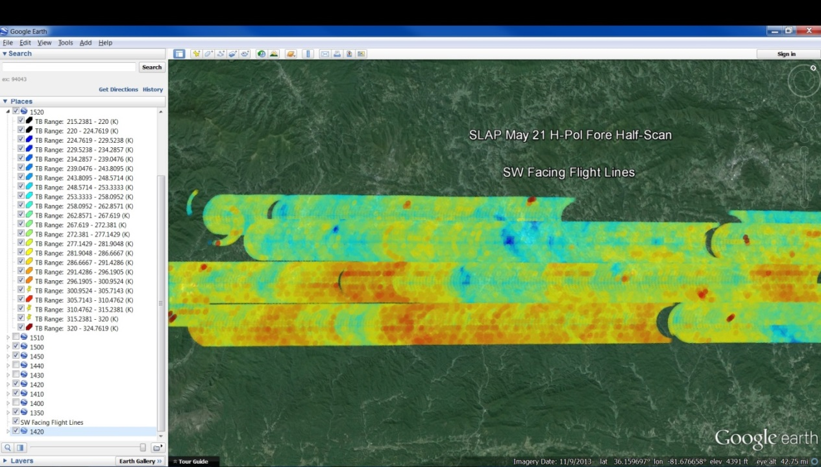

Figure 10. May 21st SW Facing Fore Half-Scan Tb Data

## Gridding

For the SLAP December 2013 flights, an attempt was made at gridding the data. Drop-in-the-bucket gridding was the method used. This procedure has not been implemented for the May 2014 flights.

# Summary of Radar Data Processing Steps

The processing steps for the radar data are mostly similar to the radiometric data, except for some key differences. The radar data is also given in ten minute data chunks. They contain radar loopback and return data. Only the return data is currently used to calculate the radar product. In the return data, there are 38 data points at each time tag, which correspond to 38 range gates. The H-pol and V-pol data consists of co-pol and cross-pol data, given in alternating time tags. The order of the co-pol and cross-pol data varies per data set and is decoded based on the pulse control module (pcm) information given in the data.

During the iPHEx campaign, radar permission was only obtained for the May 21, 2014 flight. Afterwards, it was calibrated on the ground for H-pol and V-pol. The calibration results are shown in the table below. There were many range gates that were saturated, meaning above the maximum threshold, for H and V-pol.

Table 5. SLAP Radar Ground Calibration Results

# 

The same issues with the radiometer time tags discussed in Appendix A are prevalent in the radar time tags so they must be corrected for. Then the radar data must be geolocated using the GPS receiver data as well as the scan angle data.

The next step is the core processing of the range gate data. First, the data in range gates outside of the minimum and maximum raw counts values are removed. Then the distance to each usable range gate value is calculated. The distance on the ground below SLAP at nadir to the observation point is calculated as

where R_surf is the surface radius, h is the aircraft altitude above sea level, phi is SLAP’s elevation angle, which is set to 40 degrees above nadir when the aircraft is flying level. Then the surface distance to each range gate is

where each range gate is 300 meters long and ind_(range-gate) is the index of the current usable range gate value. Finally, the range from SLAP to the observation on the ground is calculated as

Next the raw radar returns in counts are converted to power in mW them dBm using the calibration in Table 5. In the 2015 SLAP flights, the step attenuator was adjusted to keep the radar returns from saturating. This information is imported then added to the power in dBm. Afterwards, the power is converted back to mW so that it can summed. The quantity summed is the power in a current range gate multiplied by the range from SLAP to the range date as shown below.

Next, this term is plugged into the radar equation to get sigma for that observation. Finally, sigma is divided by the footprint area of that observation to get sigma_0.

The next step is averaging sigma_0 by scan angle into six degree chunks, which is approximately equal to averaging 66 sigma_0 values. Finally, before plotting onto Google Earth, the sigma_0 values are separated into fore and aft facing scans and filtered to remove data during turns.

# Appendix A – Radiometer Time Tag Anomaly

There is a hardware issue with how the radiometer observation times were tagged in the SLAP flights prior to 2015. This causes lags and jumps in the time vector. To accurately geolocate the radiometer observations, this time vector must be reconstructed. An example of the corrupted time data is shown in Figure A1.

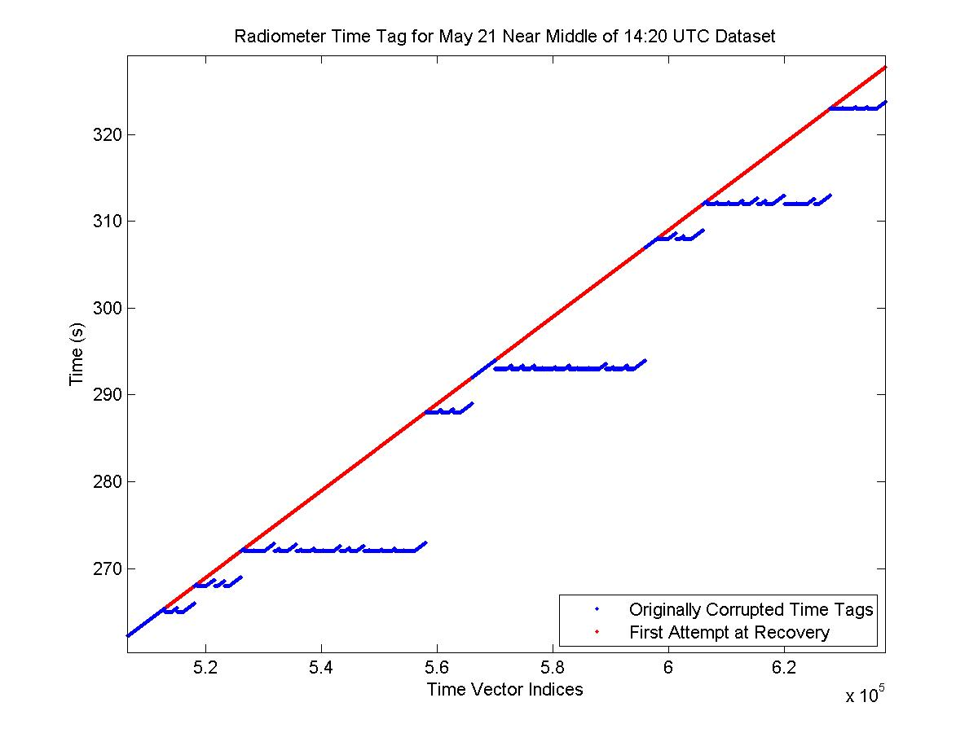

Figure A1. Example of Radiometer Time Tag Anomaly

First, it must be noted that each SLAP radiometer data set has ten minutes, or 600 seconds of data. Therefore, what is plotted in Fig. A1 is towards the middle of the data set. There are points where the time tags stall then start increasing every 2 milliseconds as expected. This happens in an expected pattern as seen in the figure so most of the time information can be reconstructed using an empirical algorithm. There are several issues with this. One is shown below in Figure A2 where the time during the 1420 UTC data set starts out with a one second jump compared to what the rest of the time data looks like, as seen after the first few data points. (The original time tags in blue start out at 10 seconds then decrease to 9 seconds before started the expected continuous increase.) If this initial one second jump is taken as the basis of what the recovered time should come from, this causes a one second offset in the first attempt at recovering the time, shown here in red. After the correct start time is chosen, the second attempt at recovery looks much more like expected, which is shown in magenta.

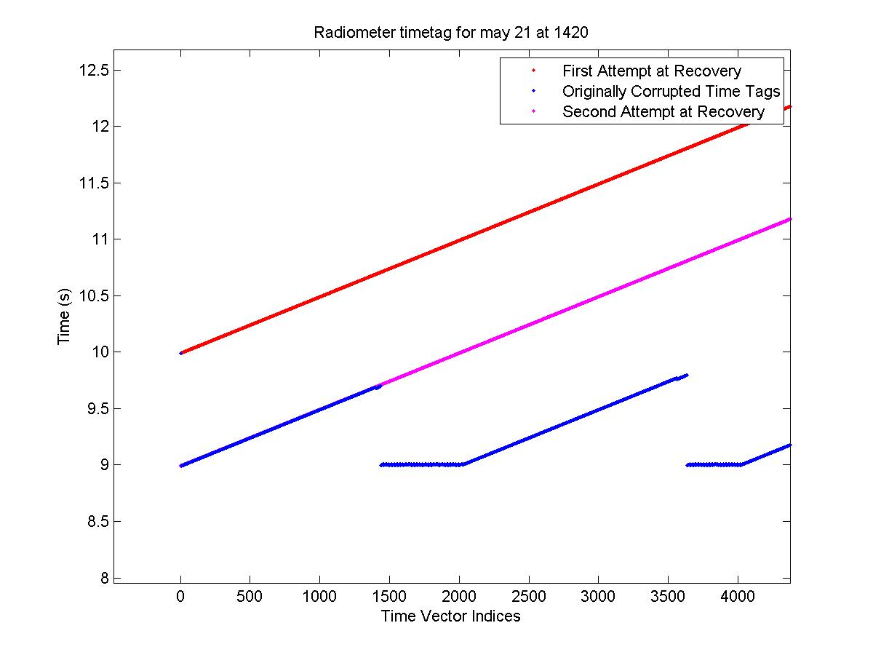

Figure A2. May 21st Radiometer 1420 UTC Data Set Unique Time Tag Anomaly

How this time offset affects the geolocation of the data is shown in Figures A3 and A4 below. A one second offset in time corresponds to a 90 degree scan angle offset since each scan requires 4 seconds. In Figure A3, the skewed brightness temperature data is visible on the part of the flight segment on the left side of the image. This is evident when compared to the 1410 UTC dataset on the right side of the image, which has two distinct streaks of high Tb values, as does the rest of the flight data. When the time tag issue is corrected as shown in Figure A4, the two steaks are at similar scan angles as they are in the 1410 data, which provides confidence the recovered time is as expected.

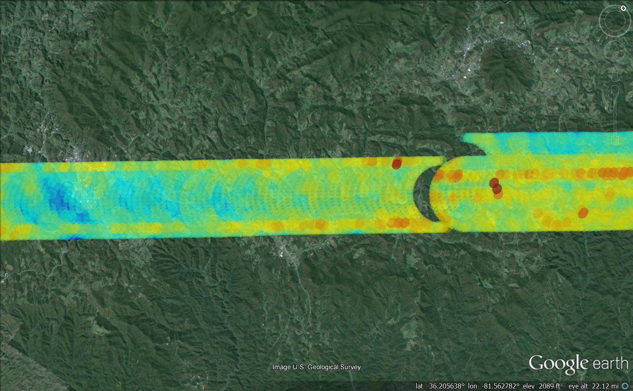

Figure A3. May 21st Flight Skewed Data at 1420 UTC

 Figure A4. May 21st Flight Corrected Data at 1420 UTC

For another part of the May 21st data, when SLAP flew over a lake after the MTL section, the original corrupted time tags lead to unexpected results when plotting counts vs time as seen in Figure A5. However, after time tag reconstruction, the counts vs time plot shown in Figure A6 makes a lot more sense as the lake observation counts are clearly visible. Figure A7 shows the SLAP fore half-scan Tb image on Google Earth when flying over the lake area. This image shows that approximately half of the scan viewed the lake and the other half viewed land. This is evident in the dips in Figure A6, which correspond to lake observations.

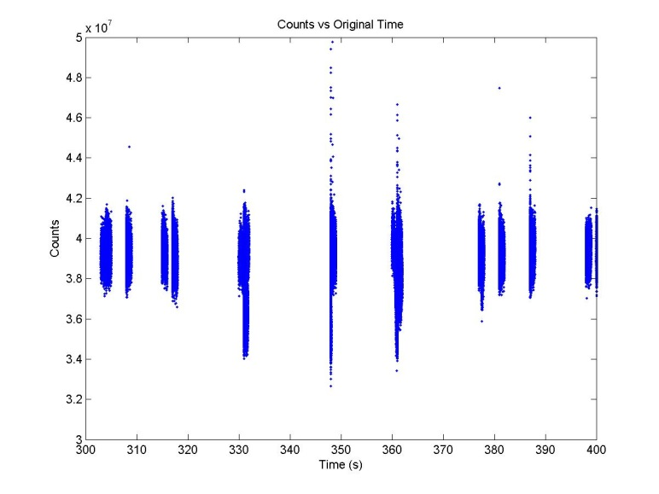

Figure A5. Counts vs Corrupted Time When Observing the Lake

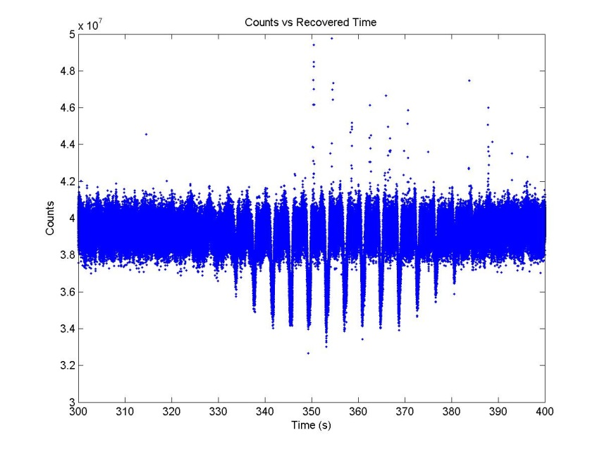

Figure A6. Counts vs Recovered Time When Observing the Lake

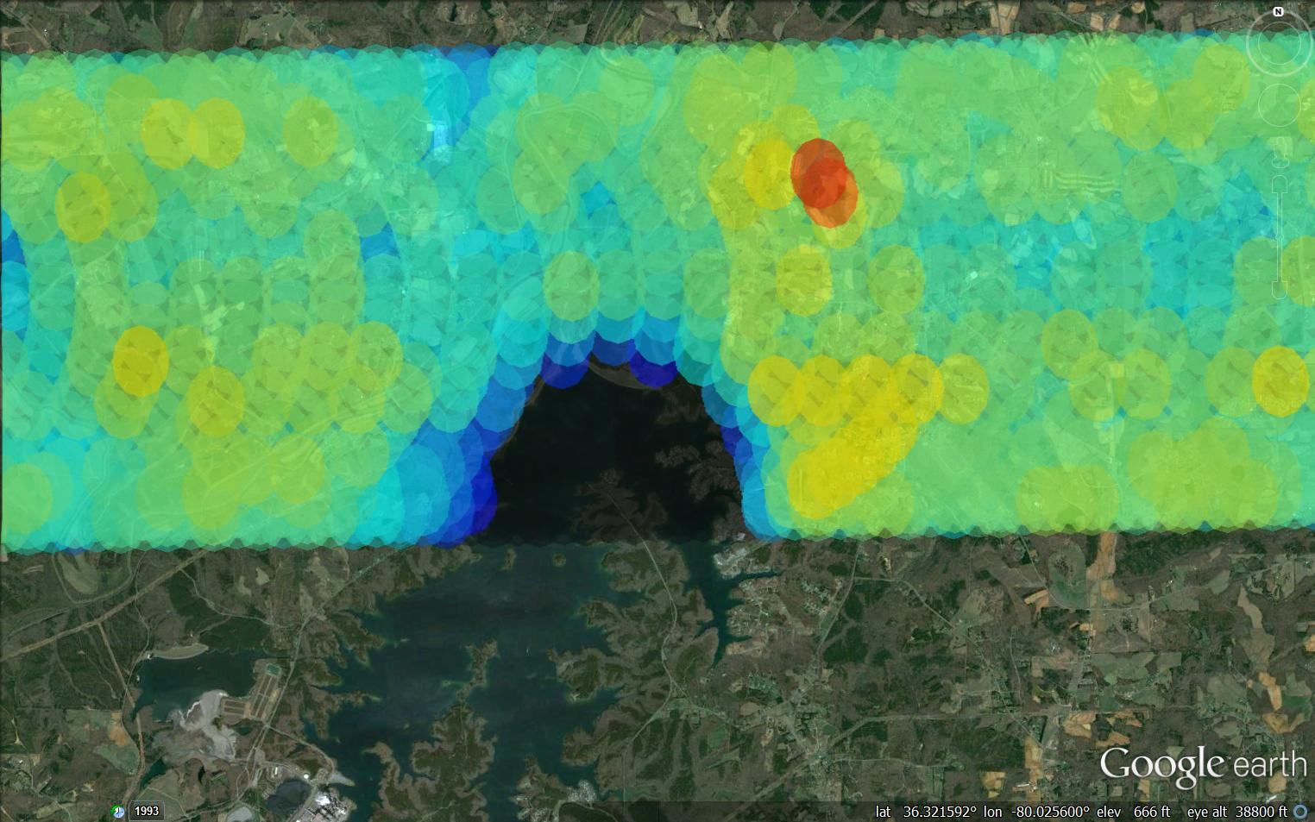

Figure A7. SLAP May 21st Fore Half-Scan Tb Data When Flying over a Lake after MTL

# Appendix B – Explanation of Long Period Cal Offset Issue by Albert Wu

This issue was corrected after the iPHEx campaign flights. The iPHEx flights introduced “SMAP Long-period Cal” mode, where two out of every six packets (8 out of every 24 PRIs) were automatically switched to the internal reference load.

Switching that crossed packet boundaries required a new tagging system to replace “op modes”, where each packet was tagged with a “pulse control mode” (PCM) based on the switch configuration during the rising edge of the first radiometer sample window of the packet.

PCM is generated by clone and saved with packet – not modified by postprocessing software.

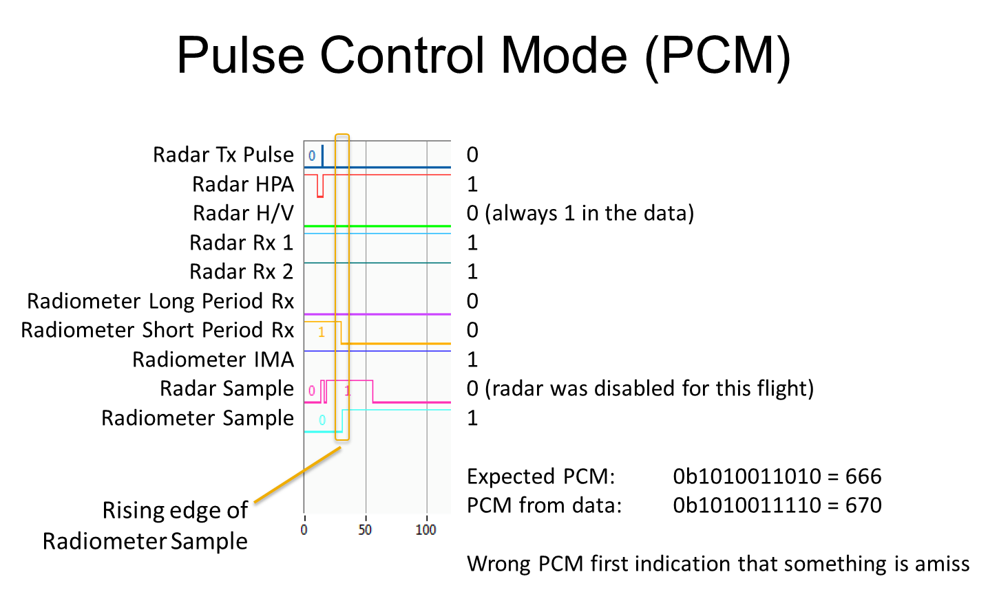

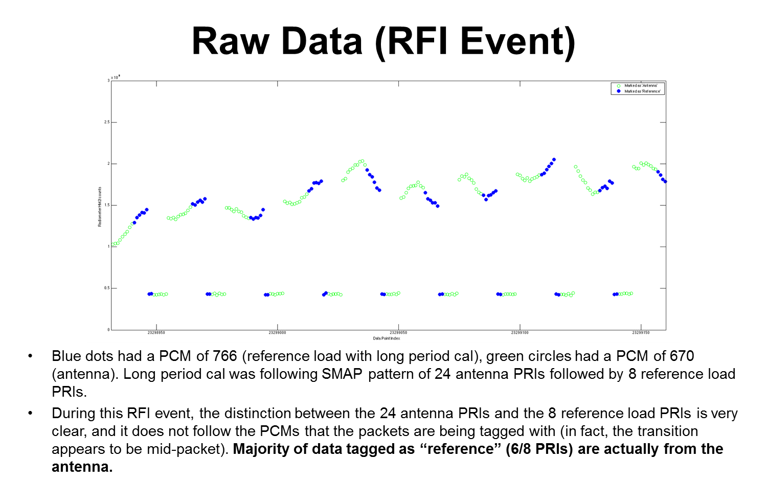

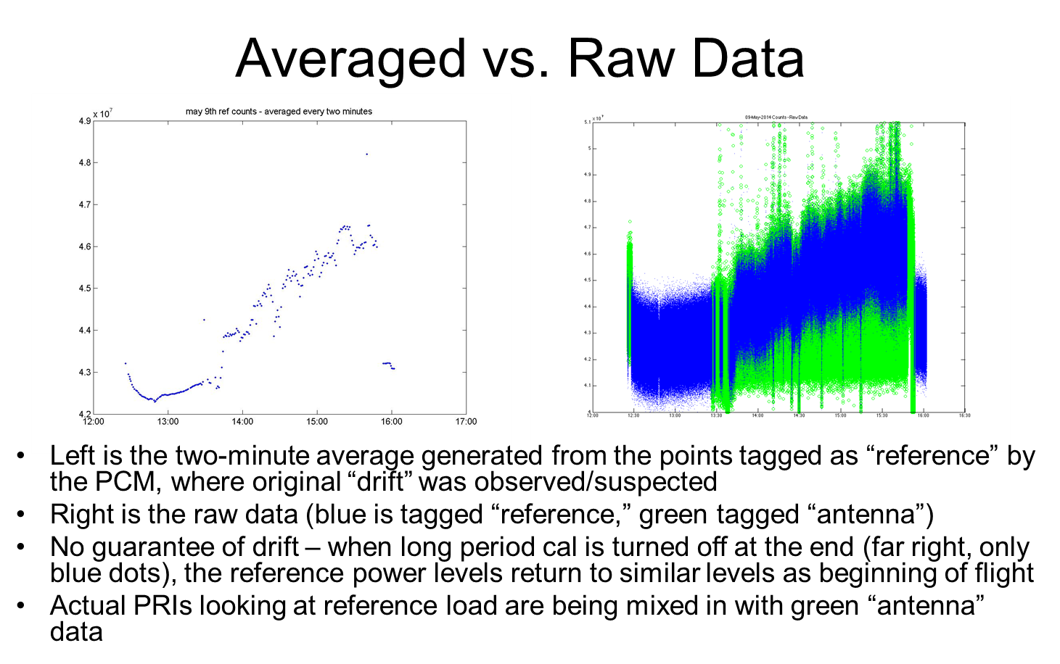

Albert Wu also wrote a code that fixed the offset issue. The user has to determine what the offset is for each individual flight segment (day and part of day, e.g. May 9th AM), but once that is found, it is very straightforward to put into his algorithm to shift the antenna and reference observation data to account for this offset. The specific values of the offsets are shown in the table below.

Table B1. Observed PCM Offset for Individual Flight Segments

|  |  |
| --- | --- |
| Flight Day and Part of Day | Observed PCM Offset |
| 21-May AM | 4 |
| 21-May PM | 0 |
| 09-May AM | 6 |
| 09-May PM | 0 |
| 05-May AM | 1* |
| 05-May PM | 0 |
| 02-May AM | 1 |
| 02-May PM | 1* |
| *There are multiple offsets in this data set. | |

An example of a fixed flight segment is shown below. The plot on the left shows the antenna and reference observations for May 9th AM pre-offset correction and the plot of the right shows them post-offset correction. There is a clear separation in the reference counts, in blue, and the antenna counts, in green, in the second plot. This is not the case in the former plot.

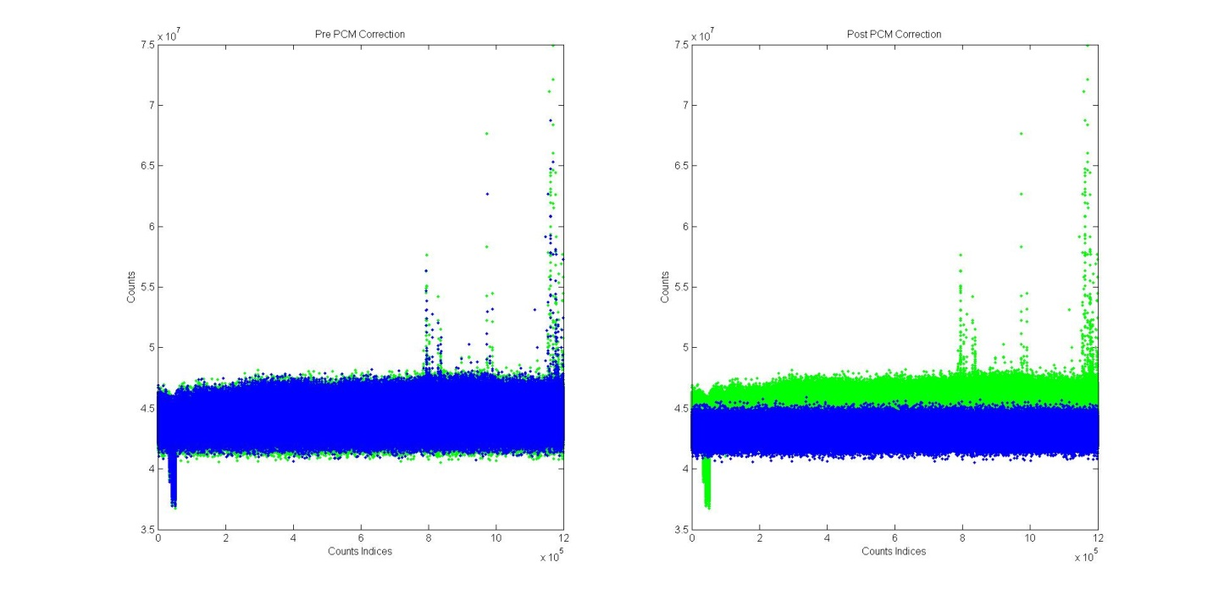

Figure B1. Pre and Post PCM Offset Correction for the May 9th 14:40 UTC Dataset

# Appendix C – M2/M1 Correction

The second power, or M2, data has to be corrected using a combination of the M2 and first power, or M1, in-phase and quadrature, or I and Q, data. Using the raw M2 counts isn’t enough to emulate the output of an analog square-law (diode) detector. To do that, the M1 component must be subtracted out. Otherwise, a time-varying bias would be left. The equations that govern this correction are specified below.

First average I and Q together for M1 and M2

Then scale with the subselect pointer

The same has to be done with M1

After this is done, the M1 component can be subtracted out with the equation

Where

# Appendix D – 1.09 Hz Peak-to-Peak Noise Mitigation

In the SLAP observations from 2014 and 2015 up to and including the February 25th flight, there was a periodic noise with characteristic 1.09 Hz peak-to-peak spikes that had to be accounted for. An example of the noise is shown in Figure F1. It was evident in flight and on the ground during foam box stares and sky stares.

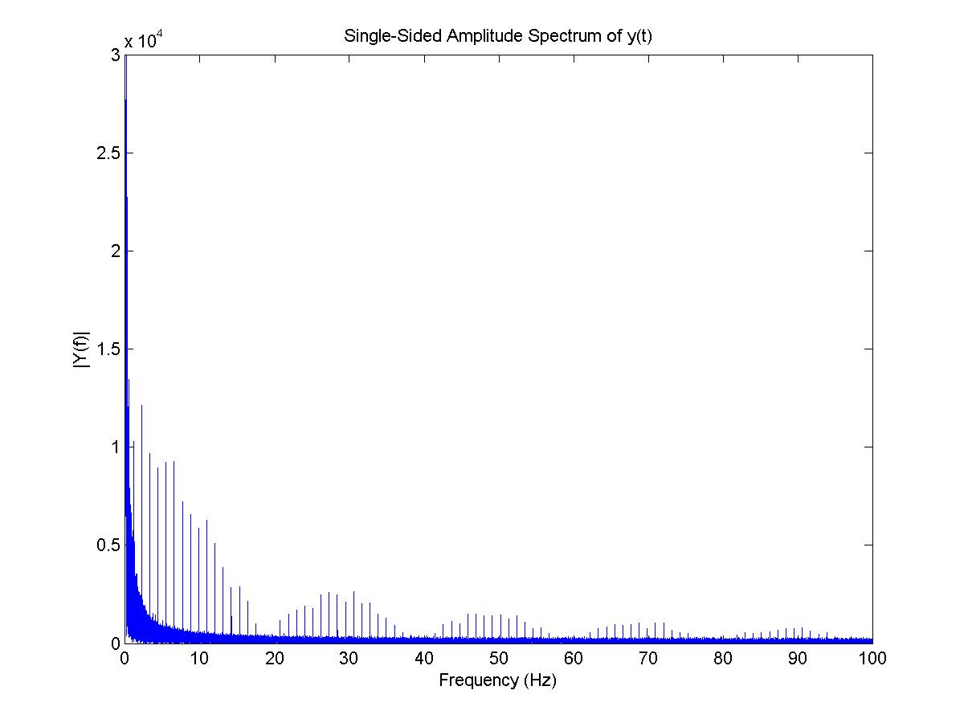

Figure F1. FFT of Sample Antenna Observations Showing 1.09 Hz Peak-to-Peak Spikes

This noise was mitigated by applying an algorithmic correction with the following procedure:

1. Take one cycle of noise: (1/1.09) seconds * 2000 data points/sec ~= 1823 data points (exact cycle length found empirically)
2. Separate 1.09 hz noise data by using a (mean minus one-sigma) minimum threshold for “actual” observations
3. Create new data set with NaN values at 1.09 Hz noise indices

This noise mitigation procedure was mostly successful in removing only the noise and not real observations, as can be seen in the sample data in Figure F2. In the H-Pol data, the algorithm removed some real observations that were below one sigma from the mean, but left the majority of the real data intact. The V-Pol noise is removed more cleanly.

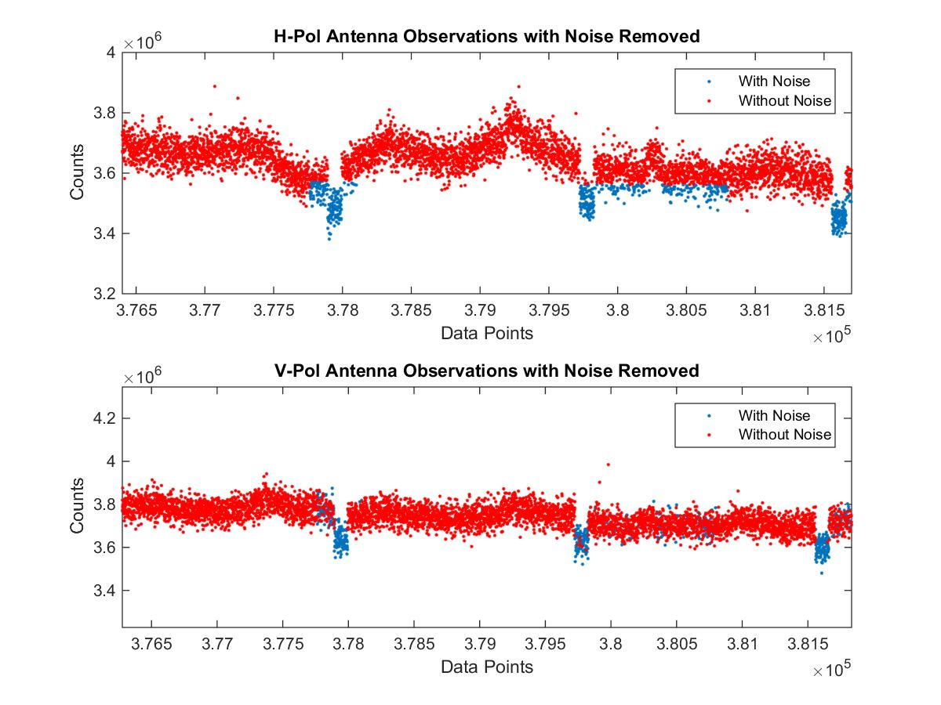

Figure F2. 1.09 Hz Noise Removal Results

This procedure was followed for all of the affected data sets. Then, several hardware sources of the noise were identified and fixes were implemented for them. The following figure shows the noise removed in the frequency and time domains. The time domain plot is shown within the frequency domain plot.

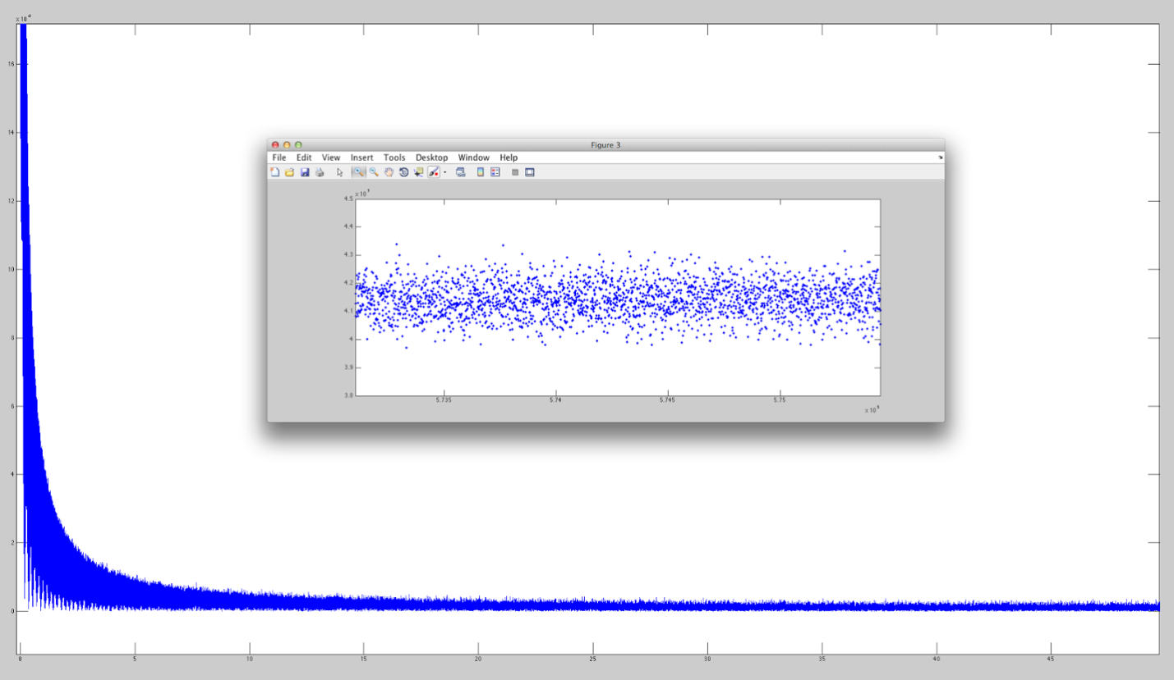

Figure F3. Sample Data in Time and Frequency Domain after 1.09 Hz Noise Removal

# Appendix E – Geolocation Procedure

As mentioned in the summary, the geolocation file is given as an excel file of the GPS receiver measurements which must be converted to a MATLAB workspace variable which includes time tags, latitude, longitude, altitude, velocity, heading, pitch, roll, and track data for the entire flight. The “importOxTSPostprocessed_v2.m” is needed to import the GPS receiver data into MATLAB. It must be mined to find the geolocation information that is needed to process the current time period of data that the algorithm is working on.

The heading and track data are given as positive clockwise (CW) when seated on the aircraft facing forward toward the nose. Since the scan angle data is given as positive counterclockwise (CCW) from the direction that points to the aircraft nose, it must be converted to be CW using

where az is the azimuthal scan angle in degrees. Then, the geolocation data is interpolated to the time frequency of the radiometer observations. This allows the assignment of a geo tag to each radiometer observed data point, at 0.5 ms increments. The lat/lon coordinates are only for aircraft nadir, not the locations of SLAP’s observations on the ground. To calculate those, the following procedure must be used.

The altitude of the aircraft and the incidence angle of SLAP’s observations are necessary to determine the radius on the ground from aircraft nadir to the location of SLAP’s current observation. The equation is

Where r_surf is the surface radius, alt is the altitude of the aircraft and theta is SLAP’s incidence angle, which is 40 deg from nadir when the aircraft is flying level (no roll). Next, the total azimuth angle must be determined, which is

where az_SLAP is the azimuthal scan and hdg_aircraft is the aircraft heading.

A depiction of the geometry is shown below.

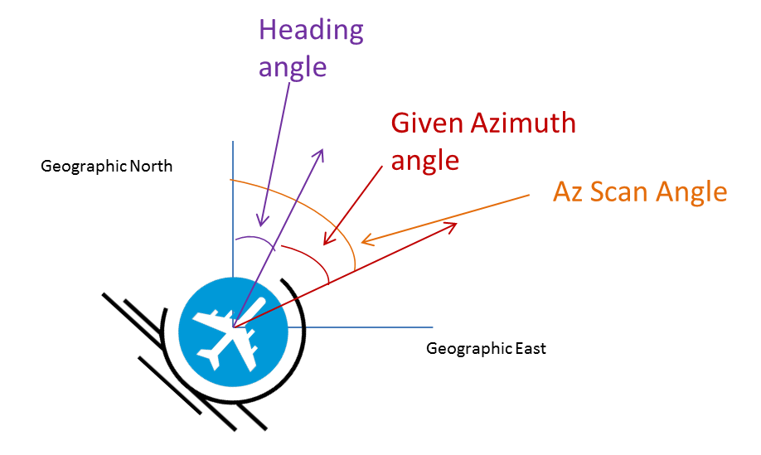

Then, the distances in the horizontal and vertical directions to the current SLAP observation from aircraft nadir can be determined using

Where x_off is the offset distance in the cross-track direction on the ground which is in line with the pitch axis of the aircraft and y_off is the offset distance in the along-track direction on the ground which is in line with the aircraft’s roll axis. A diagram of the scenario is shown below.

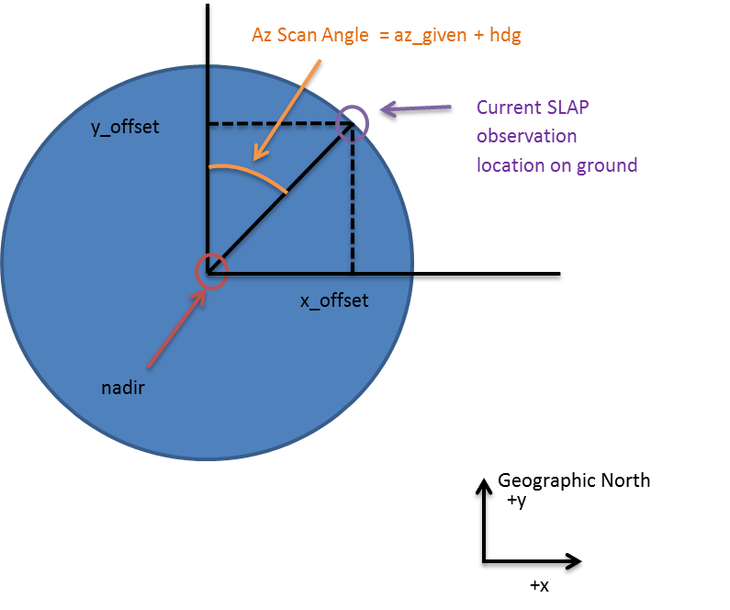

Note in the diagram that SLAP’s observation is depicted as a circle, while in reality it is an ellipse. This is used as an approximation. Now to convert x_off and y_off to lat and lon coordinates for each SLAP observation, the following equations must be used.

Where lat_aircraft and lon_aircraft are the interpolated lat/lon coordinates of aircraft nadir and r_Earth is the radius of the Earth.

The next set of diagrams illustrate the footprint geometry. Since the instrument is rotating CCW as the plane is flying forward, the rightmost footprint occurs before the leftmost footprint below.

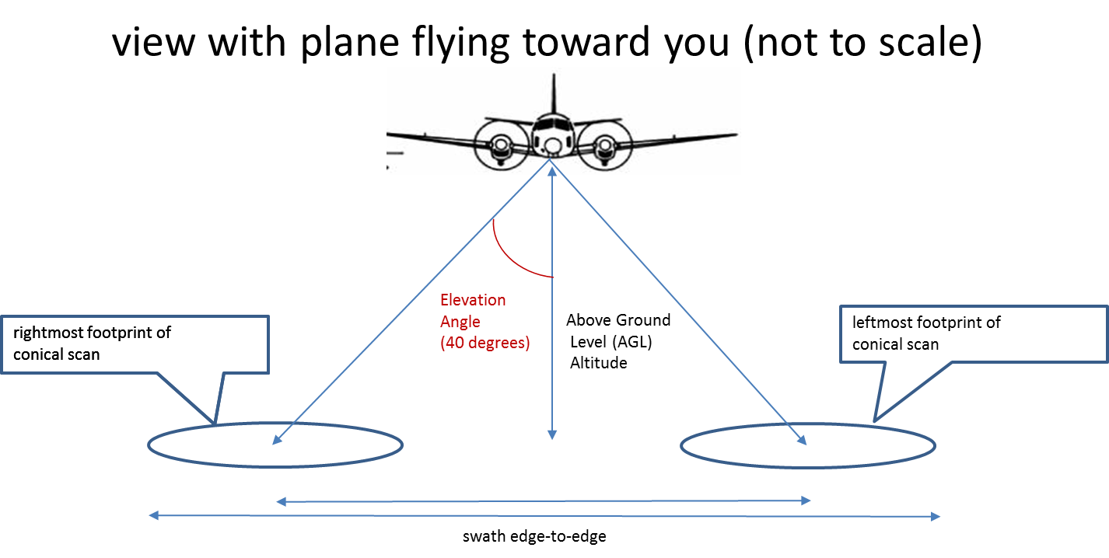

Next is a figure that shows the full cycle of SLAP observations. This is just for illustration as it is not accurate with respect to the number of observations per one cycle, which is actually 2000.

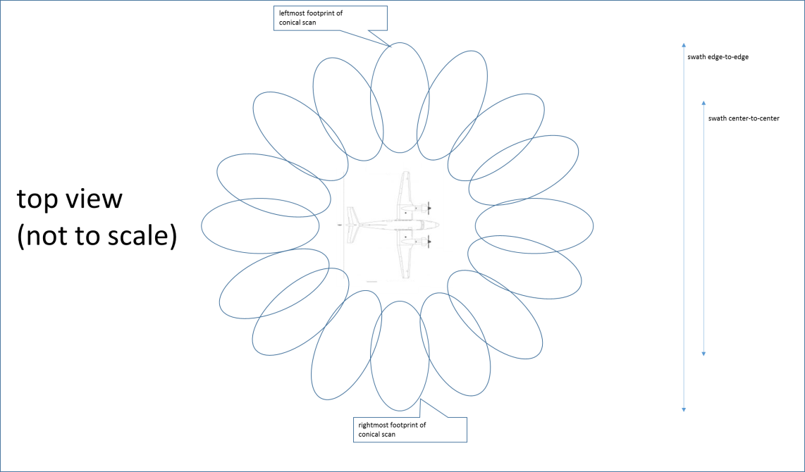

The next diagram shows how the wind affects the data plotted on Google Earth. If the intended track is due North, the aircraft must be turned into the wind so the required heading angle is non-zero. The track angle is defined CW from due North and is the angle the ground flight path makes with respect to due North. The heading angle is also defined CW from due North and is the angle the aircraft nose makes with respect to due North. Therefore, the yaw angle is defined as the difference between the heading angle and the track angle.

In the Google Earth images, the fore and aft half scans are generated with respect to the intended track angle, not the heading angle.

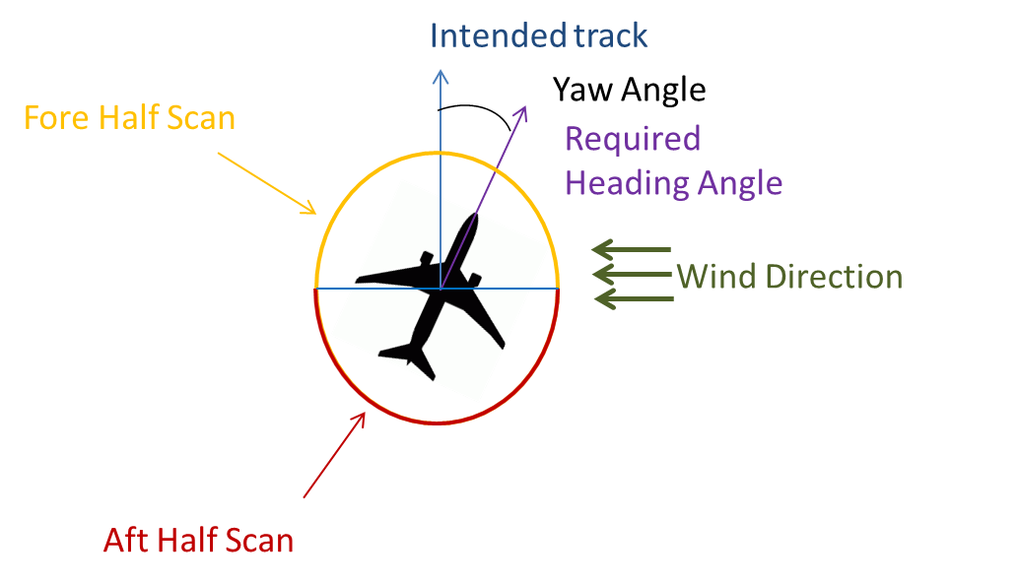

# Appendix F – Calculation of NEDT

In the calculation of NEDT, the sky and foam box cal mean values were obtained as discussed in the “Two Point Calibration” section. The equation to calculate NEDT is shown below.

(D1)

T_a is the antenna temperature, which is the radiometric temperature of the target being viewed, which we report at 300 Kelvin. Bandwidth is specified as 24 MHz. Tau is the integration time. Since three spans of 1000 data points are used that are taken 0.0005 seconds apart, this mean taue is 1.5 seconds.

T_rec is the radiometer’s self noise, determined from the sky and foam box cal data from April 21st. Specifically, it is the y-intercept on the line that connects the sky and foam box data points on the temperature versus counts plot. The figure below shows the plot.

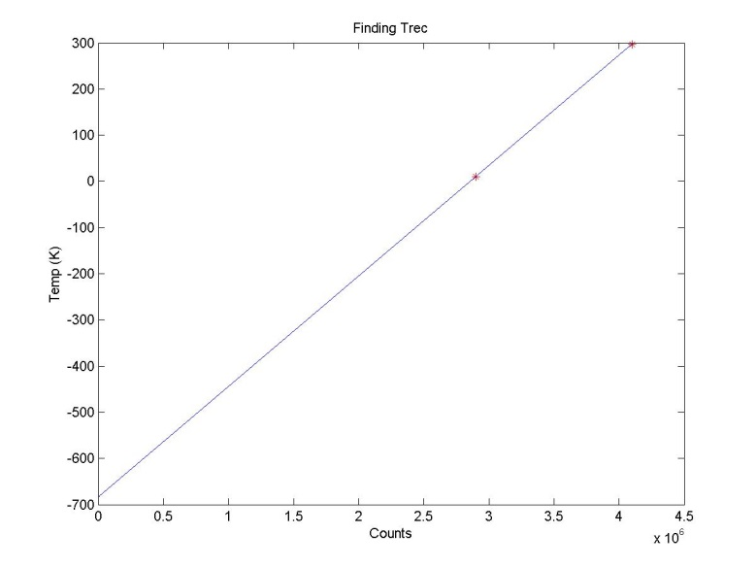

Figure D1. Linear Fit to Two Point Cal Between Sky and Foam Box Observations to Determine T_rec

The y-intercept of the line above is at -684 K. The absolute value of this number is taken as T_rec. Now all of the NEDT equation terms are defined. This leads to the following NEDT values.

Table F1. NEDT Values for H and V Polarizations

|  |  |
| --- | --- |
| NEDT H-Pol | 0.164 K |
| NEDT V-Pol | 0.148 K |
| Observation Time Period | 1.5 sec |

# Appendix G – Flowchart of Radiometer Product Generation Process

Adjust antenna and reference data sets to fix the offset, then save to MATLAB workspace file with RAD filename

Convert raw RAD data using SLAP_L1B_32.m into MATLAB workspace variable

Was there a PCM offset between antenna and internal target observation data?

Yes

No

Read in RAD.mat, ENC, DAQ, files for one 10 minute data set at a time

Pull in geolocation information for current time tag duration

Interpolate rad time tags to 0.0005 second values

Repair rad time jumps using custom algorithm

Change azimuth angle data to linearly increase steadily as opposed to recycling after 360 deg

Interpolate azimuth angle data to frequency of Rad data

Generate Google Earth image for current 10 minute data set either for Tb or SM then repeat process for next 10 minute data set

Tb to Soil Moisture Algorithm

If soil moisture values are desired, run Tb values through SM algorithm

If all data points have been iterated through, exit loop, otherwise continue

Perform linear interpolation between sky observation and foam box observation to convert each individual raw counts value to a brightness temperature

Iterate over index of 6 degree average data point values

Obtain sky observation data performed before flight campaign

Obtain foam box observation data performed before flight campaign

Interpolate azimuth angle data to frequency of Rad data

Create flags to be able to plot data on only fore or aft half-scan

Average all Rad data as well as geolocation data to 6 degree azimuth angle increments

Create flag to remove data when the plane is turning by using roll max values

Find indices of azimuth angles that are within 6 degree increments

Perform geolocation for each data point as described in Appendix D

Interpolate geolocation data to frequency of Rad data